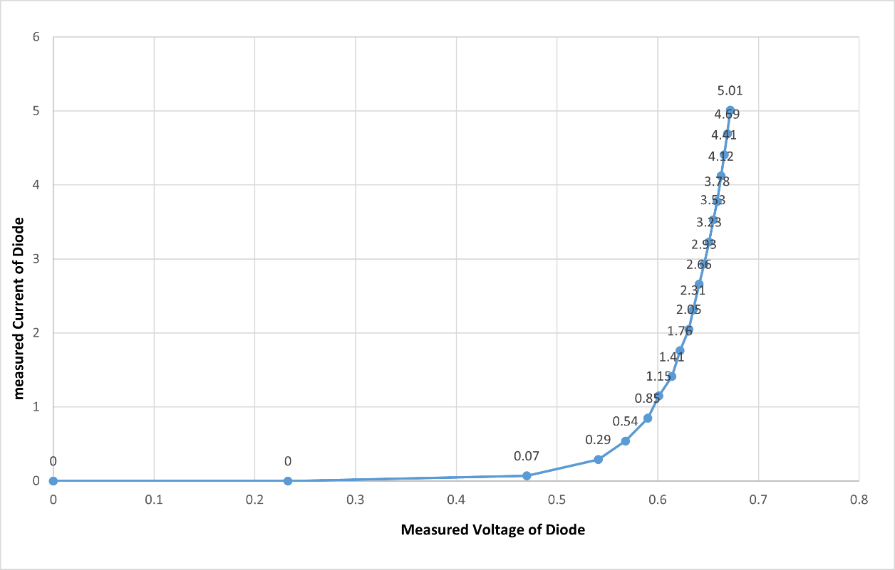
Expected Webforms:
Graph 1.1: $I_{D}$ VS $V_{D}$
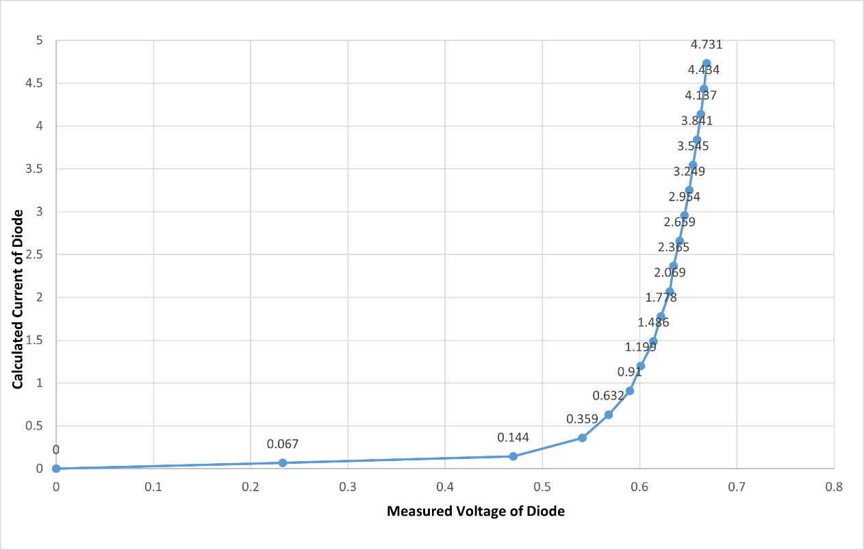

Graph 1.2: $\frac{V_{DC}-V_{D}}{R}$ VS $V_{D}$

